Building AI solutions we can trust*
People often call generative AI a "black box". Large language models (LLMs) are random, and they hallucinate. Ask an LLM question X and it answers Y. Ask X again and this time, it answers Z. That randomness makes Copilot a great conversation partner. It also makes it easy to assume that anything built on an LLM is inherently untrustworthy.
IPAVentures helped produce one of the first generative AI chatbots in the Australian Government. The public have direct access, with no human checking each answer before it goes out.
So, how do we reconcile that? How do we make a system publicly accessible, with no human in the loop, and remain confident that it’s not going to go all ‘Skynet’ on us…or worse, provide legal advice! We’ve done a lot of work to answer this question, so I'd like to share this and explain how a trustworthy* AI system can be made.

Measuring what matters
A lot of ink has been spilled on the "proper" use of generative AI in the Australian Government, and even more in government generally. After having read quite alot of that documentation, in my opinion, the most fundamental requirement is that:
We need to be able to understand/see and explain the outcome of an AI driven system because, we remain accountable for its output.
How can we know if a system is operating ‘ethically’ if we can't explain how or why it responds the way it does? How can we judge the residual risk if we can't see the effect of a control we've just implemented?
However complex an AI system is, if we can see and explain how it works, we're well placed to take the next step and actually influence its behaviour.
Once we can influence a system in a way we can see and explain, the next big hurdle is doing it consistently. Consistency is the real trick. It's what lets an organisation take accountability for the output of a system that uses an LLM.
That’s not to say we have to understand and explain every tiny detail of a system works…
-I like to think of it like the movie Ratatouille. No one in the movie understands how or why the rat, tugging on the chef’s hair moves an arm or a finger but through a bit of trial and error, the rat learns which hairs to pull to make the chef move in particular ways. After enough trial and error, we’re able to understand, to the extent we need to, how and what to manipulate to make the system behave a particular way, be it cooking a meal or providing the public with information about intellectual property.
By consistent, I don't mean the system uses the same words every time. I mean it's statistically probable that the system produces a result that falls within an acceptable range.
The rest of this post explains how you prove that, using a tool called a test harness, with one of our projects, a “Data Expert Agent”, as a worked example.

What is a test harness?
A test harness is a piece of equipment that runs the same exam on an AI system, over and over, marks every answer the same way, and keeps the results.
Think about how you'd assess a new staff member before letting them answer public enquiries on their own. You wouldn't ask them one question and call it done. You'd give them a set of realistic questions where you already know what a good answer looks like. You'd mark their answers against a clear rubric. You'd keep a record, so you could see whether they improve after training. And you'd want an experienced colleague to check the marking was fair.
A test harness does exactly that for an LLM, except it can run thousands of questions overnight. It has five parts:
- A question bank. Hundreds of realistic questions, each paired with a model answer or the facts a good answer must contain. It also includes trick questions the system should decline, such as questions outside its subject.
- The system under test. The AI tool we're assessing. It answers every question in the bank, exactly as it would for a real user.
- The judge. A second LLM that marks each answer against a written rubric. Did it stick to the source material? Did it answer the question? Did it make anything up?
- The scoreboard. Every question, answer and mark is recorded, so we can compare one version of the system with the next.
- Human calibration. People mark a sample of the same answers by hand. If the judge and the humans disagree too often, we fix the judge before trusting it.
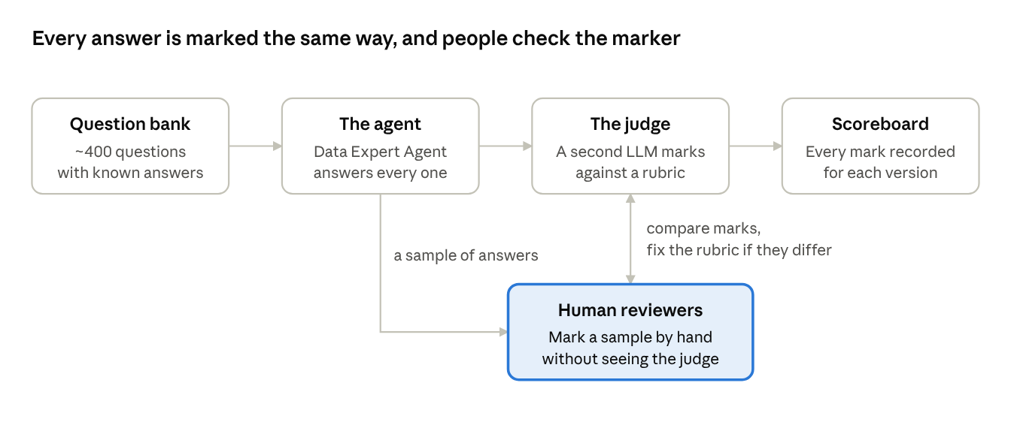
test harness · 4 stages and a human check
The agent answers every question, the judge marks every answer, and people mark a sample so we know whether to believe the judge.
The important shift is this. We stop asking "did it give a good answer?" about a single conversation. We start asking "how often does it give a good answer, and how sure are we of that number?"

Case study: the Data Expert Agent
Draft note: the figures in this post are illustrative. Swap in the real numbers once the harness run is complete.
The Data Expert Agent is an AI assistant that answers questions about data management: governance, data quality, lineage, storage and the like. Its knowledge comes from one trusted source, IBM's The 2026 Guide to Data Management, a library of 124 articles.
It works the way most trustworthy chatbots do. When you ask a question, it doesn't answer from the LLM's general memory. It first searches the library for the most relevant passages, then writes an answer using only what it found, and points to the articles it used. This approach is called retrieval-augmented generation, or RAG. It's the same basic pattern behind many government chatbots.
That design gives us something concrete to test. A good answer from this agent must do four things:
- Stay grounded. Every claim should be supported by the IBM articles it retrieved, not invented.
- Answer the question. A grounded answer about the wrong topic is still a bad answer.
- Cite the right source. The articles it points to should be the ones that actually contain the answer.
- Know its limits. Asked about something outside data management, it should say so politely rather than improvise.
To build the question bank, we used the library itself. While loading each article, an LLM writes a handful of questions that article can answer. Because we know which article each question came from, we know where the right answer lives. We topped these up with real questions from colleagues, which are messier and more realistic, and a set of out-of-scope questions designed to tempt the agent into guessing.
The result is a bank of around 400 questions. Each one is run through the agent, and each answer is marked by a judge LLM against those four tests. One question is an anecdote. Four hundred is evidence.

Using an LLM to judge an LLM
This is usually where the incredulity kicks in. If LLMs are random and unreliable, why would we trust one to mark another?
The short answer is that we don't, at first. We earn that trust in three ways.
Judging is an easier job than answering. The agent has to search a library, choose what's relevant and write something useful. The judge gets a much narrower task: here is the source text, here is the answer, does every claim in the answer appear in the source? Checking a sum is easier than doing it. Narrow, well-defined tasks are where LLMs are most dependable.
We check the judge against people. Before we rely on the judge, a person marks a sample of the same answers by hand, without seeing the judge's marks. We then compare the two. If they agree often enough, the judge can carry the load. If they don't, we rewrite the rubric and test again. The next sections explain how that comparison works.
We let scale do the heavy lifting. This is the part that turns a random tool into a reliable measurement. Yes, the agent and the judge both have some randomness. But randomness behaves predictably when you have enough of it.
Think about flipping a coin. Flip it 10 times and get 7 heads, and you can't say much. Fair coins do that all the time. Flip it 1,000 times and get 700 heads, and you can be very confident the coin is biased. Each flip is still random. The pattern across many flips is not.
The same applies to our pass rate. Suppose the Data Expert Agent passes 90% of its test questions. How much should we trust that 90%? It depends entirely on how many questions we asked. The chart below shows the range the true pass rate probably sits in (a 95% confidence interval) for different numbers of test questions.
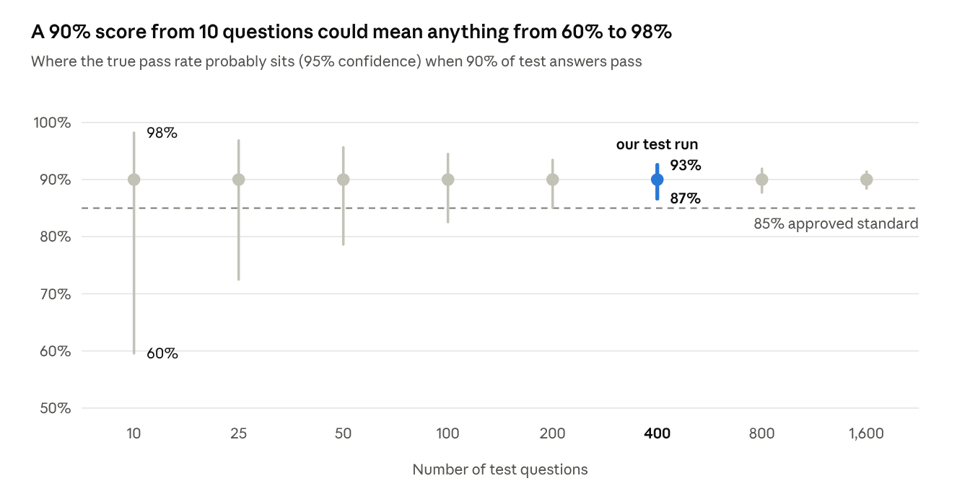
calculated · 95% confidence interval for a 90% pass rate, 10 to 1,600 questions
The extra questions don't make the agent any better. They make our measurement of it precise enough to act on. Notice too that the range narrows more slowly as you go: to halve it, you need roughly four times as many questions. That's why test sets for systems like this run to hundreds of questions, not dozens, and why we need an automated judge to mark them.

Hypothesis testing: assume it's not good enough, then look for proof
A confidence range tells us how precise our measurement is. Hypothesis testing lets us make a formal yes or no decision from it, with a known chance of being wrong.
The easiest way in is a courtroom. An accused person is presumed innocent. The prosecution has to bring enough evidence to overturn that presumption "beyond reasonable doubt". If the evidence falls short, the verdict is "not guilty". That isn't the same as "innocent". It just means the case wasn't proven.
Hypothesis testing works the same way, with two competing statements:
- The null hypothesis is the default position we assume until the evidence overturns it. It's the courtroom's "presumed innocent".
- The alternative hypothesis is the claim we'd like to prove. It's what the prosecution is arguing.
Here's the useful part for government. We get to choose which side carries the burden of proof. For the Data Expert Agent, we put it on the system. Say the organisation decides that at least 85% of answers must be fully grounded in the source material before the agent goes live. Then:
- Null hypothesis: the agent does not meet the standard. Its true grounded rate is 85% or lower.
- Alternative hypothesis: the agent does meet the standard. Its true grounded rate is above 85%.
In other words, we start from the sceptic's position. The agent is assumed not good enough until the evidence says otherwise.
We also decide, before we run any tests, how much doubt we'll accept. A common choice is 5%. That means we'll only reject the null hypothesis if results this good would happen less than 5% of the time by luck, from an agent that really was only at 85%. That probability is called the p-value. A small p-value means "this is very unlikely to be a fluke".
Now the evidence. Suppose the agent scores 90% in two different test runs:
Test run | Questions | Grounded answers | p-value | Verdict
Small | 20 | 18 (90%) | 0.40 | Not proven. An 85% agent would score this well 4 times in 10.
Full | 400 | 360 (90%) | 0.002 | Proven. An 85% agent would score this well about 1 time in 470.
Same score, opposite conclusions. The only difference is the amount of evidence.
The same method answers the question I raised at the start: did a new control actually work? Suppose we add a stricter instruction telling the agent to say "I don't know" when the library doesn't cover a question. Before the change, 82% of 400 answers were grounded. After, 90%. The null hypothesis here is "the change made no difference, and the improvement is just noise". With 400 questions on each side, the p-value is about 0.001. We can say, with evidence, that the control worked.

The confusion matrix: how we check the judge
Earlier I said we check the judge against people before trusting it. The tool for that is a confusion matrix. Despite the name, it's just a two-by-two grid that counts the four ways a yes/no test can turn out.
Most Australians now know one well, even if they've never heard the term. A rapid antigen test for COVID can be:
- True positive: it says you have COVID, and you do.
- True negative: it says you don't, and you don't.
- False positive: it says you do, but you don't. Annoying, but you'll find out.
- False negative: it says you don't, but you do. This is the dangerous one, because you go about your day.
Our judge is a test too. Its job is to flag answers that contain something not supported by the source. For the Data Expert Agent, a person marked a sample of 200 answers by hand, without seeing the judge's marks. We treated the person's mark as the truth and counted where the judge agreed.
The grid below shows the result. Of the 30 answers the person found to be ungrounded, the judge caught 27 and missed 3. Of the 170 good answers, it wrongly flagged 8.
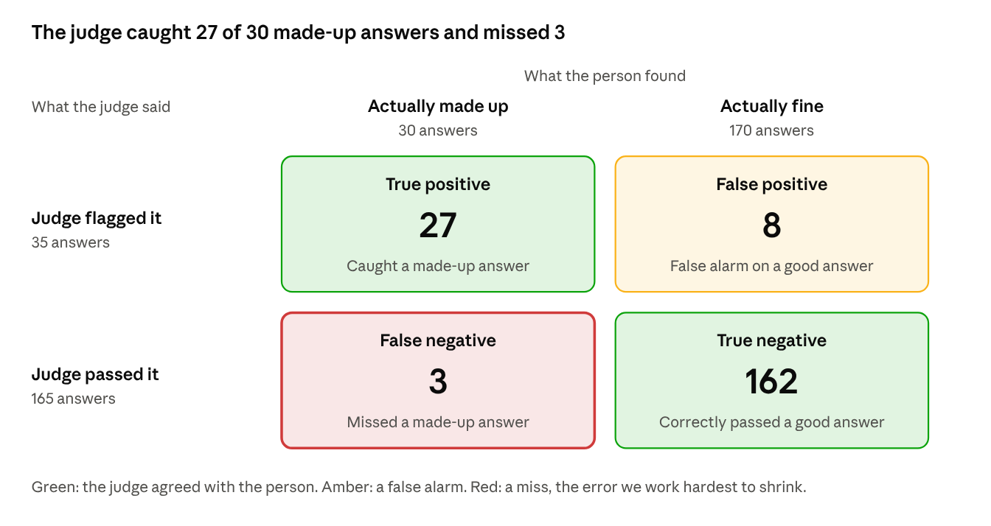
illustrative · 200 Data Expert Agent answers marked by the judge and by a person
Every answer lands in exactly one box, so the four numbers always add up to the 200 answers checked.
From those four numbers we get the measures that matter:
- Overall agreement: 189 of 200, or 94.5%.
- Catch rate (statisticians call it recall): 27 of 30 bad answers caught, or 90%.
- False alarm share: 8 of the 35 flags were wrong, so about 1 flag in 4 is a false alarm.
As with the COVID test, the two kinds of error aren't equally bad. A false alarm costs us a few minutes of a person's time to check. A miss is worse: it lets a made-up answer through and makes the agent look better than it is. So we deliberately tune the judge to be strict, and accept more false alarms in exchange for fewer misses.
Knowing these error rates has a second benefit. Because we know the judge misses about 1 bad answer in 10, we can adjust the agent's headline score for it, rather than pretending the judge is perfect.
The same four boxes also apply to our go-live decision from the last section. A false positive there means declaring the agent ready when it isn't. We limit that risk by setting the 5% threshold in advance. A false negative means holding back an agent that was actually good enough. We limit that by asking enough questions.

From numbers to accountability
Put all of this together and the organisation can make a statement it can stand behind. Something like:
Tested against 400 questions, the Data Expert Agent gave fully grounded answers 90% of the time. We're 95% confident the true rate is between 87% and 93%, which is above our approved standard of 85%. Answers were marked by an automated judge that agrees with human reviewers 94.5% of the time.
That's very different from "we tried it and it seemed fine". It names the standard, shows the evidence, admits the uncertainty and sets the decision rule before the results came in. It's also repeatable. Every time we change a prompt, swap a model or update the library, we rerun the same 400 questions and see whether the numbers moved. And because the world changes, we keep sampling real conversations to check the test bank still looks like what people actually ask.
This is what lets us be accountable for a system with randomness built in. We can't promise what any single answer will say. We can show, with evidence, how often answers fall within the approved range, and we can see straight away when that changes.

About that asterisk
Trust here comes with conditions, and it's worth being upfront about them.
- A 90% pass rate means 1 answer in 10 falls short. Statistics tells us how often, not which ones. That's why the approved range has to reflect the real-world risk of a bad answer, and why a public-facing tool needs clear signposting and a way to reach a person.
- The results only hold for questions like the ones we tested. If people start asking things our question bank doesn't cover, the numbers stop applying. That's why the bank needs refreshing from real use.
- The judge and the humans can share blind spots. Calibration shows they agree, not that both are right. Periodic review by genuine subject matter experts still matters.
So when I say trustworthy*, I mean this: trusted to perform within a measured, approved range, for the kinds of questions we've tested, and re-checked every time something changes. That's not blind faith in a black box. It's the same standard of evidence we'd expect from any other system the public relies on.

